Network Infrastructure Plan for National Children’s Hospital

Shehab Ahmed – C00295178

IP Addressing Scheme
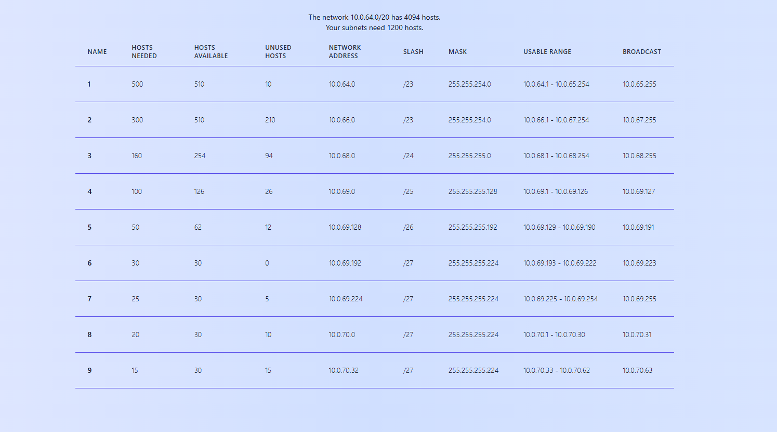
Figure 1 – St. James’s (STJ) VLSM plan

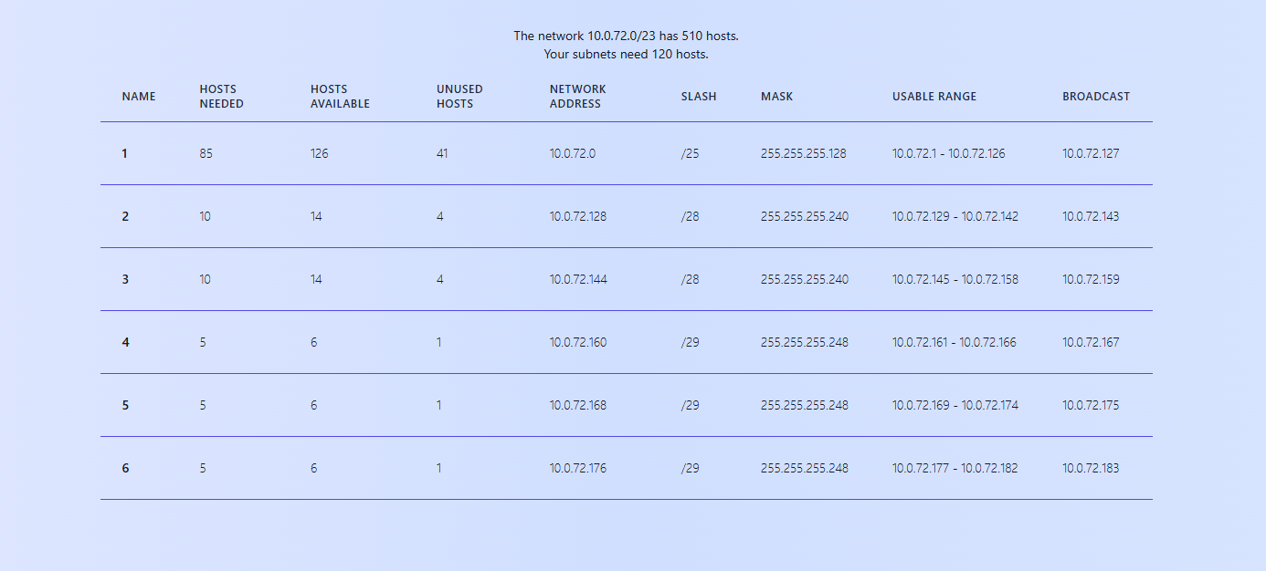
Figure 2 – Digital Health & Research Hub (DH&RH) VLSM plan
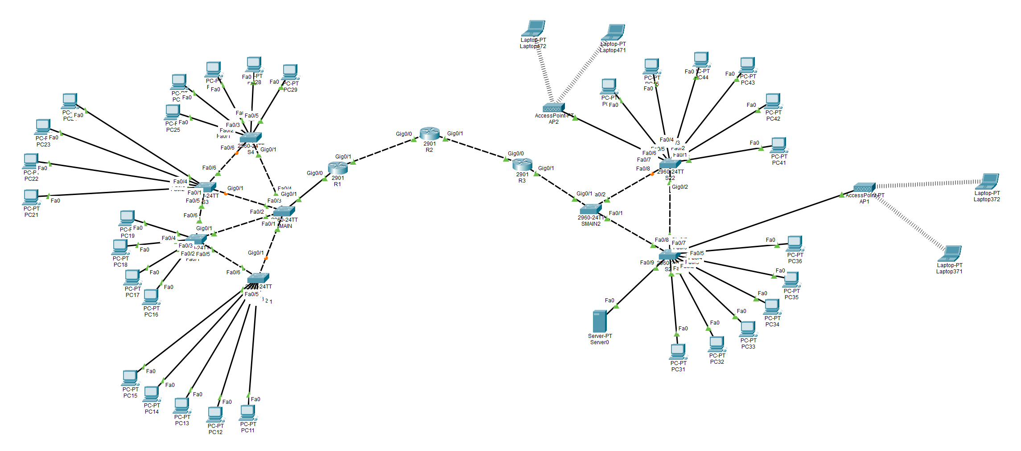
Figure 3 – Topology for 2 hospital LANs (STJ on the left, DH&RH on the right)
Note: First usable and last usable IP addresses are assigned to first and last devices on the VLANs. Last usable IP addresses -1 are set on the router sub-interfaces. (With an exception to WLANs in DH&RH - 10.0.73.0/24 with DHCP implemented)

Steps 1 / 2:
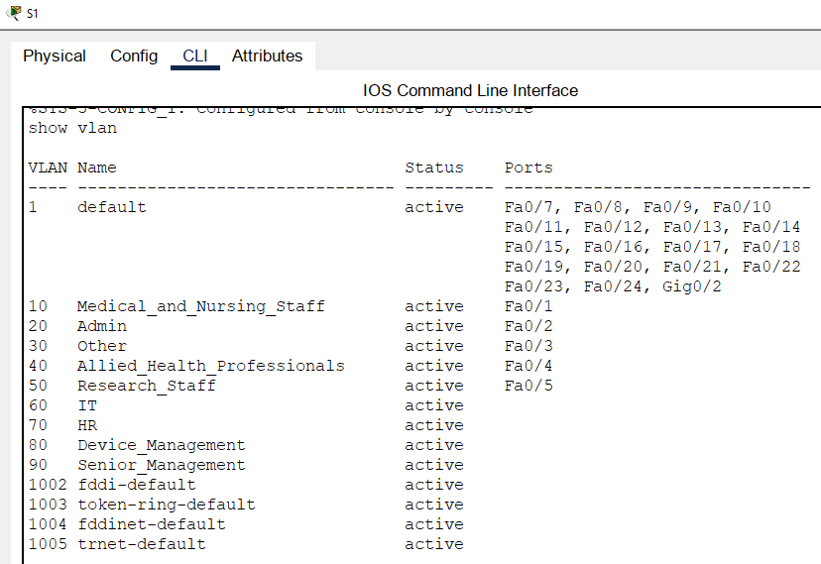
Figure 4 – STJ S1 “show vlan” command
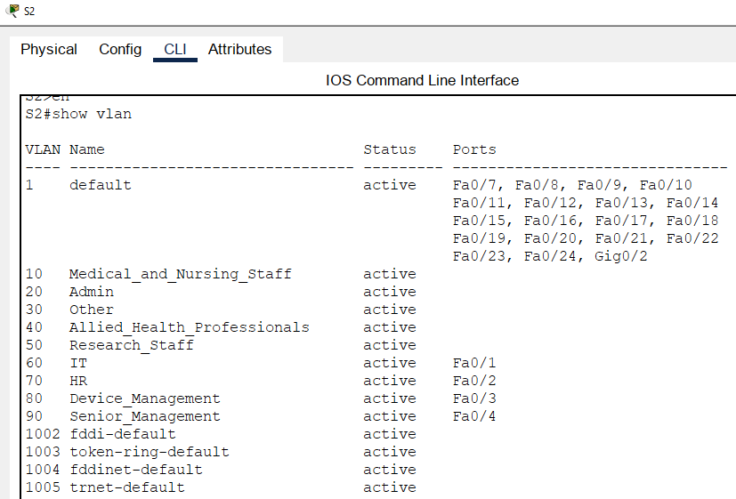
Figure 5 – STJ S2 “show vlan” command

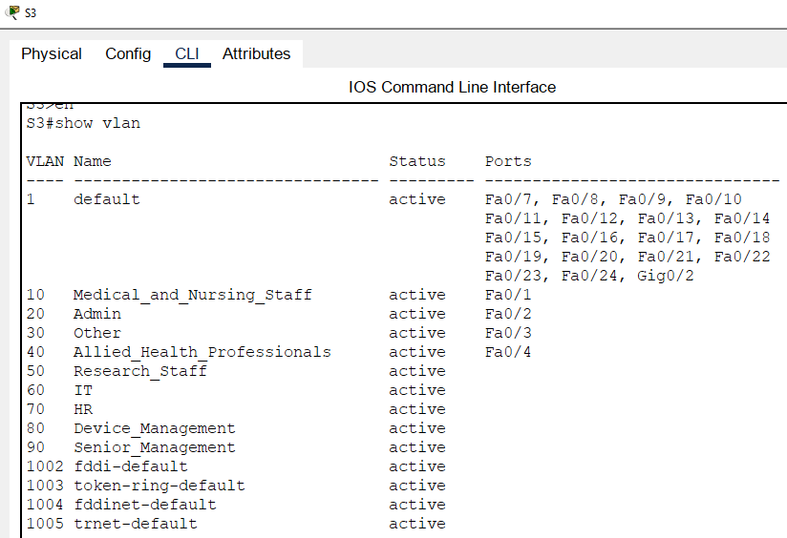
Figure 6 – STJ S3 “show vlan” command

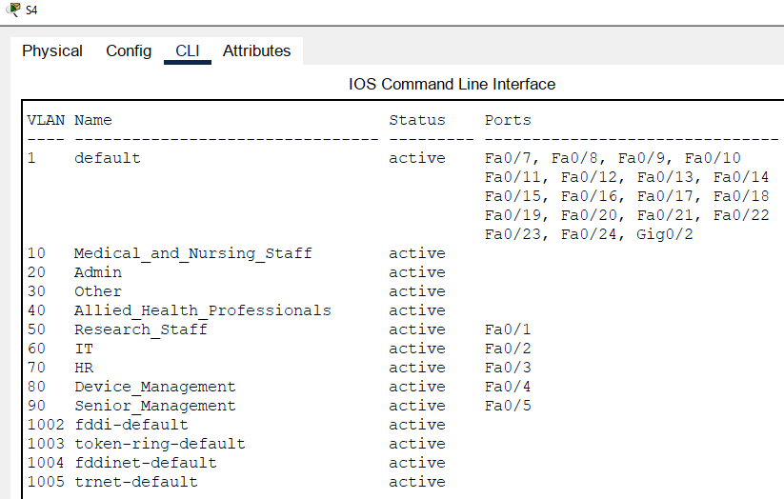
Figure 7 – STJ S4 “show vlan” command

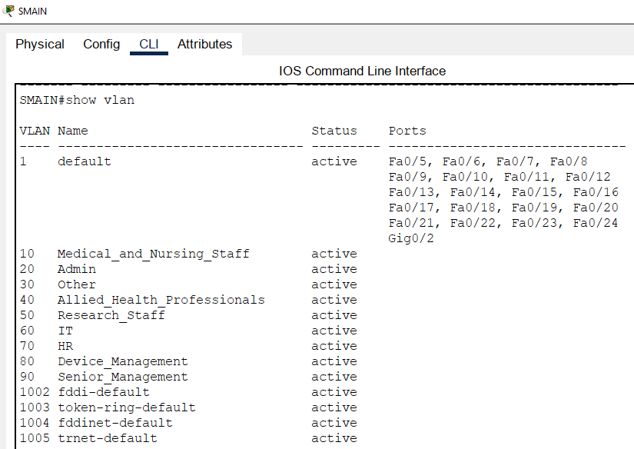
Figure 8 – STJ SMAIN “show vlan” command
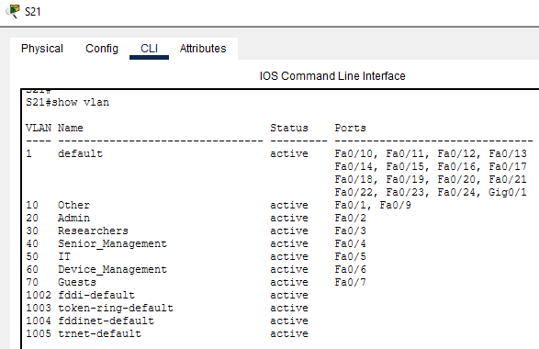
Figure 9 – S21 “show vlan” command

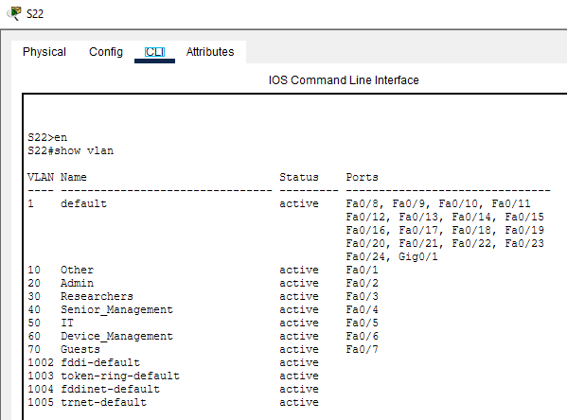
Figure 10 – S22 “show vlan” command
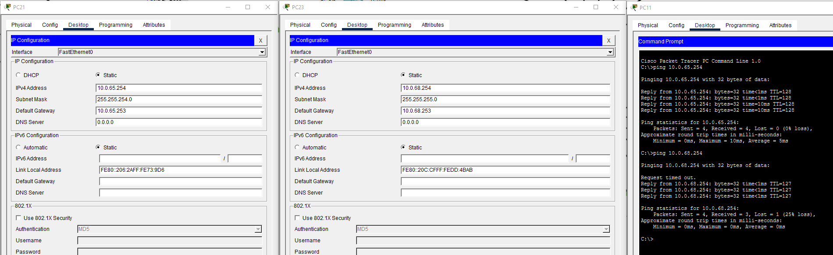
Figure 11 – VLAN 10 to VLAN 10 and Inter-VLAN Routing demonstration

Step 3:
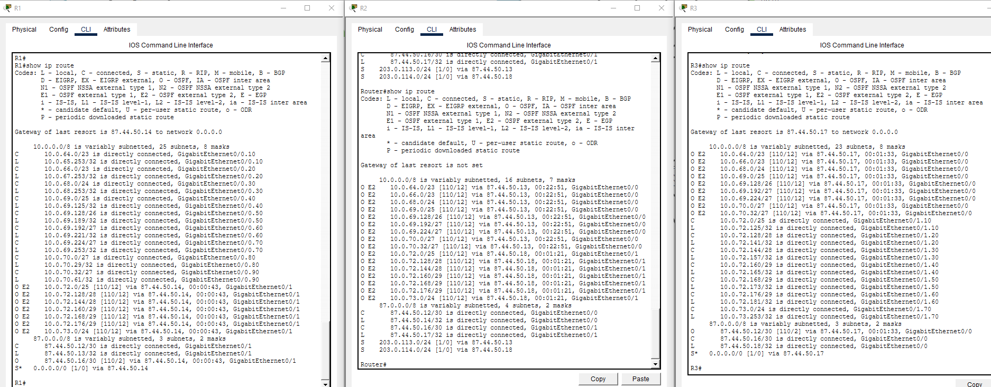
Figure 12 – “show ip route” command demonstrates the full functionality of OSPF

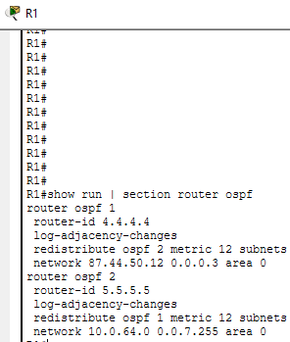
Figure 13 – ospf configuration on R1. Redistribute both sides to each other
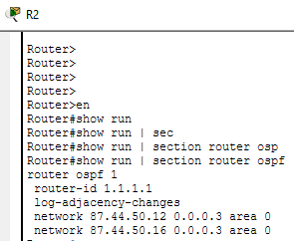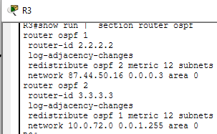
Figure 14 - ospf configuration on R2 Figure 15 – ospf configuration on R3

Step 4:
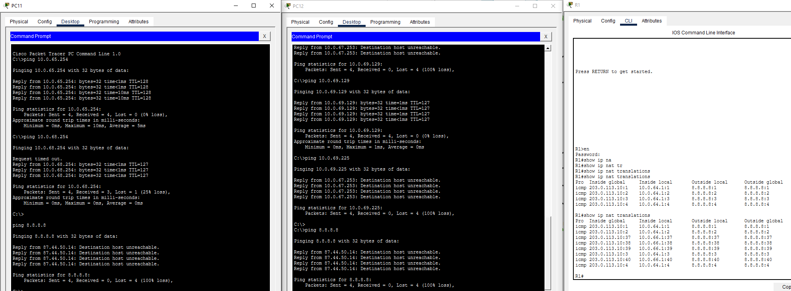
Figure 16 – “show ip nat translations” command after pinging the internet from 2 devices
Note: 8.8.8.8 shouldn’t be reachable and shouldn’t ping. This is because it doesn’t exist. The packet leaves the router via default route and the source address gets translated then stored in its NAT translations table. This demonstrates PAT functionality.
Step 5:
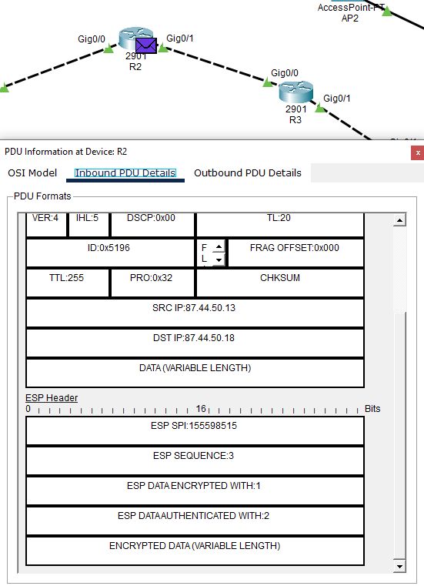
Figure 17 – Encrypted packet content during transmission between R1 and R3 at R2
Note: content of packet at R2 is encrypted. This is due to the encryption method over VPN tunnel between R1 and R3. When packet reaches DH&RH, packet is decrypted using the shared key at R3 and content is restored to plaintext.

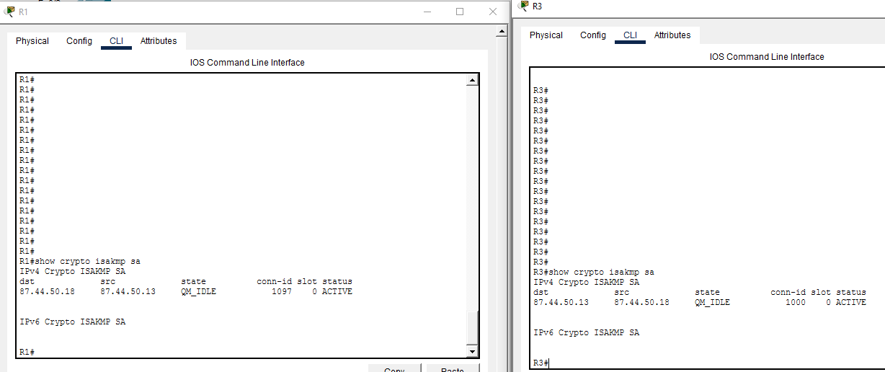
Figure 18 – “show crypto isakmp sa” on R1 and R3

Step 6:
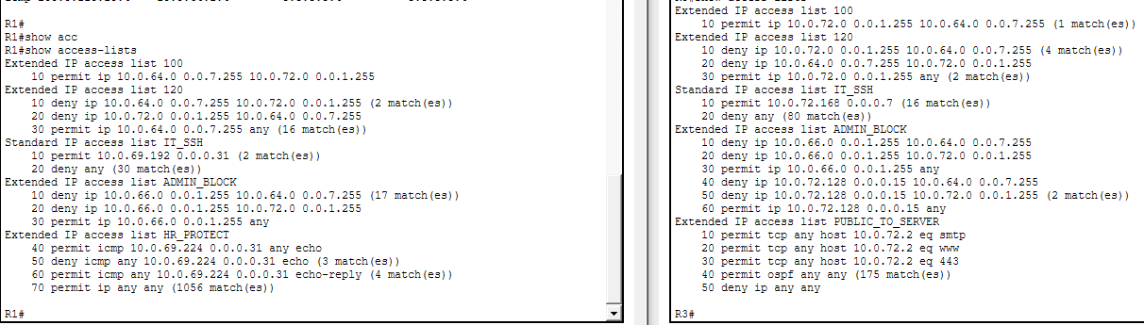
Figure 19 – “show access-lists” command on R1 and R3
- IT_SSH access list allows only devices in the IT VLAN to access routers via SSH (Figure 13 below shows what interfaces and sub-interfaces these access lists were implemented on)
- ADMIN_BLOCK can simply only access devices that are NOT on the network – on the internet. Pinging devices inside the network as an admin will result in the packet being dropped.
- Only in STJ network could this be implemented because DH&RH doesn’t contain HR VLAN. Any ICMP echoes sourced from HR devices are permitted. Any ICMP echoes sourced from non-HR devices are denied. Any ICMP echo-replies to HR devices are permitted. This is to bypass the stateful limitations of ACLs.
- PUBLIC_TO_SERVER permits any requests to the server “Server0” on 3 ports only – 25, 80, 443. Since this is implemented on the outside port of R3, “permit ospf any any” is needed to allow ospf traffic into the router. Otherwise, the routing table would be incomplete.

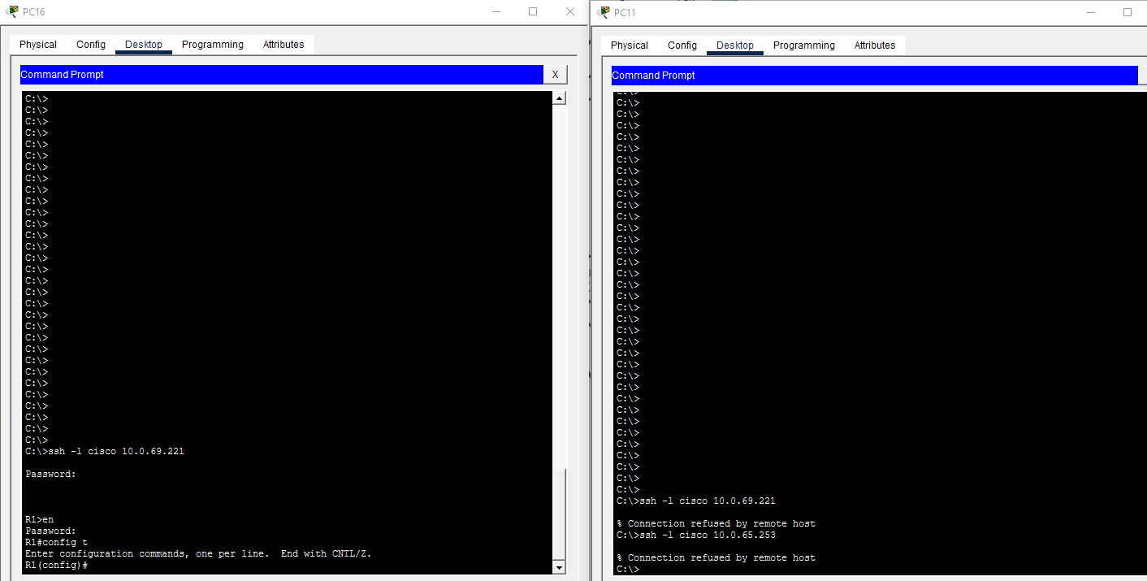
Figure 20 - Only IT staff can SSH into R1. Other devices can’t, despite their own default gateway
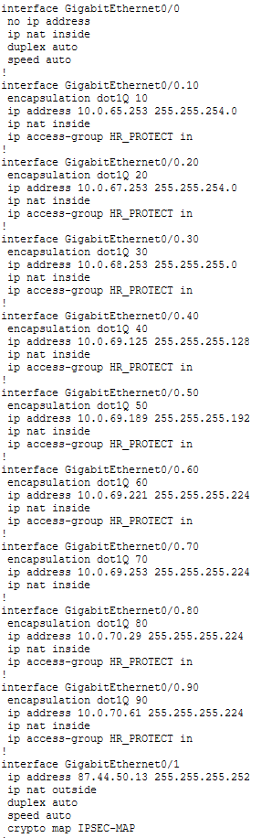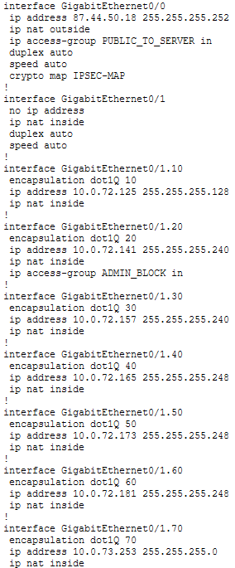
Figure 21 – “show run” access-lists R1 Figure 22 – “show run” access-lists R3

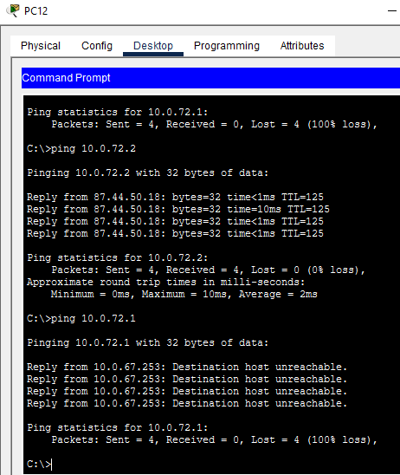
Figure 23 – Cross-site ping to DH&RH server (10.0.72.2) from STJ Admin successful – ping to 10.0.72.1 unsuccessful (dropped)
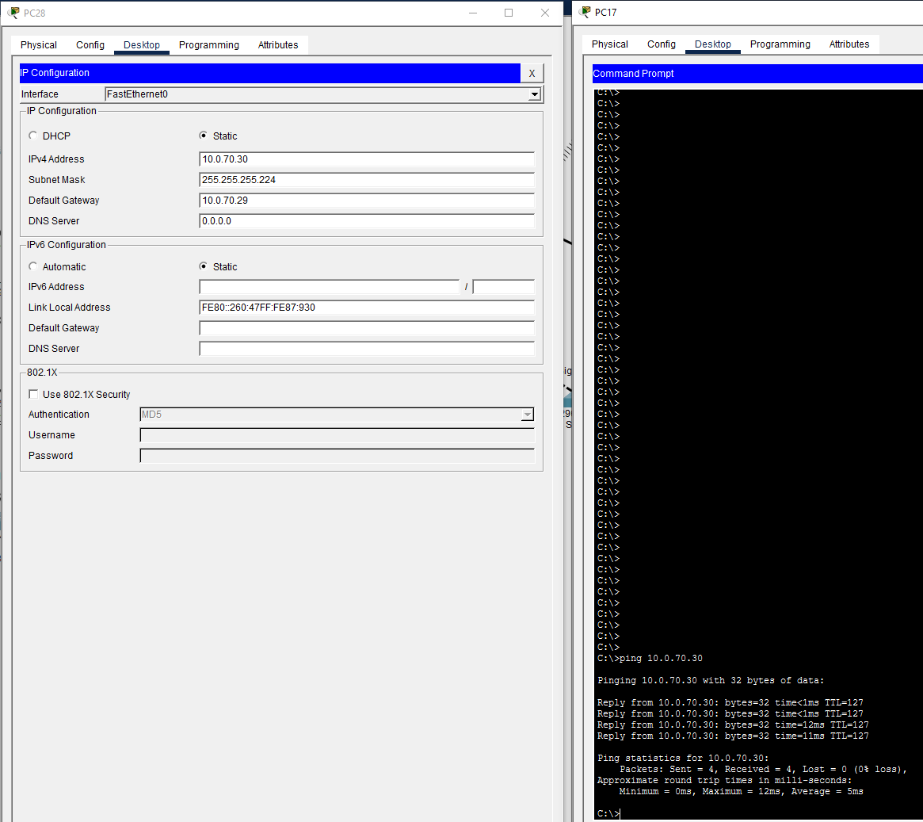
Figure 24 – Ping from HR to non-HR successful

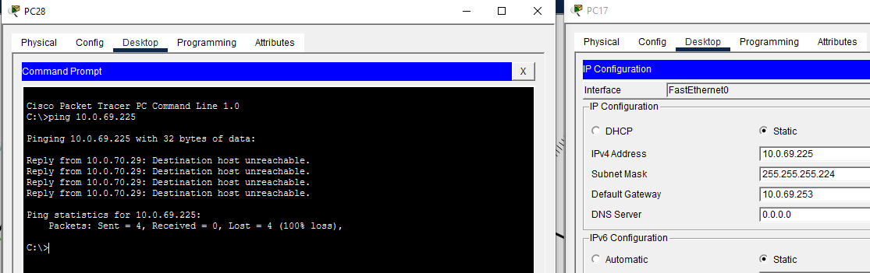
Figure 25 – Ping from non-HR to HR unsuccessful

